Project Design Phase-II

Data Flow Diagram & User Stories

|  |  |
| --- | --- |
| Date | 15 October 2022 |
| Team ID | PNT2022TMID24961 |
| Project Name | Web Phishing Detection |
| Maximum Marks | 4 Marks |

# Data Flow Diagrams:

A Data Flow Diagram (DFD) is a traditional visual representation of the information flows within a system. A neat and clear DFD can depict the right amount of the system requirement graphically. It shows how data enters and leaves the system, what changes the information, and where data is stored.

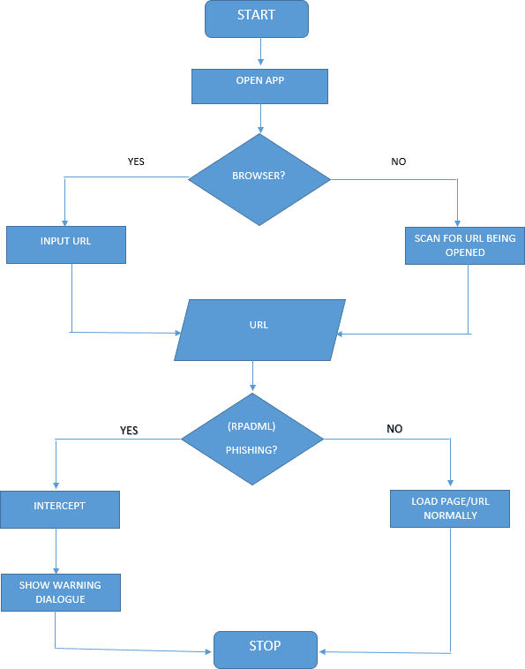

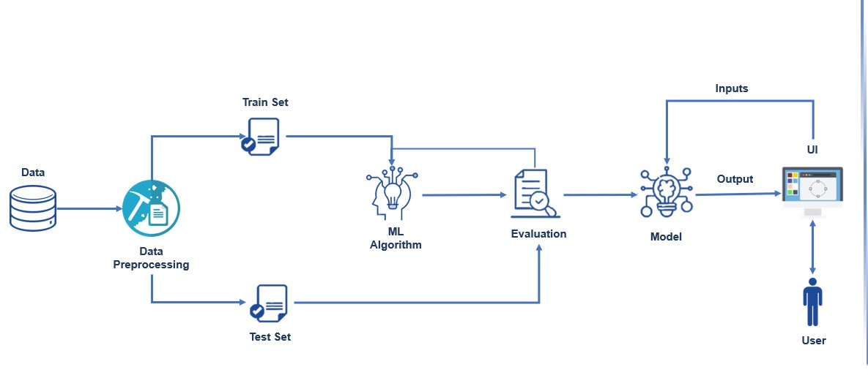

**Architecture Diagram:**

# User Stories

Use the below template to list all the user stories for the product.

|  |  |  |  |  |  |  |
| --- | --- | --- | --- | --- | --- | --- |
| **User Type** | **Functional**  **Requirement (Epic)** | **User Story Number** | **User Story / Task** | **Acceptance criteria** | **Priority** | **Release** |
| Customer (Web user) | Registration | USN-1 | As a user, I can register for the application by entering my email, password, and confirming my  password. | I can access my account / dashboard | High | Sprint-1 |
|  |  | USN-2 | As a user, I will receive confirmation email  once I have registered for the application | I can receive confirmation  email & click confirm | High | Sprint-1 |
|  |  | USN-3 | As a user, I can register for the application through LinkedIn | I can register & access  the dashboard with LinkedIn Login | Low | Sprint-2 |
|  |  | USN-4 | As a user, I can register for the application  through Gmail | I can register & access the  dashboard with Gmail Login | Medium | Sprint-1 |
|  | Login | USN-5 | As a user, I can log into the application by  entering email & password | I can access my account  / dashboard | High | Sprint-1 |
|  | Dashboard | USN-6 | As a user, I paste the Link that needs to  be Verified as a Phishing site or not | I can paste the Link  into the Textbox | High | Sprint-1 |
|  |  | USN-7 | As a user,I can see the Result | I can view that it is a Safe  Site | High | Sprint-1 |
| Customer Care Executive |  | USN-8 | As a user,I can Share my Queries in the Help  Textbox | I can send my Doubts through it | Medium | Sprint-1 |
| Administrator |  | USN-9 | As a Administrator, I can Answer the User Queries | I sent the Solution through  User provided Email | High | Sprint-1 |
|  |  | USN-10 | As a Administrator, I can  Improve the Accuracy | I can update the Website | High | Sprint-1 |